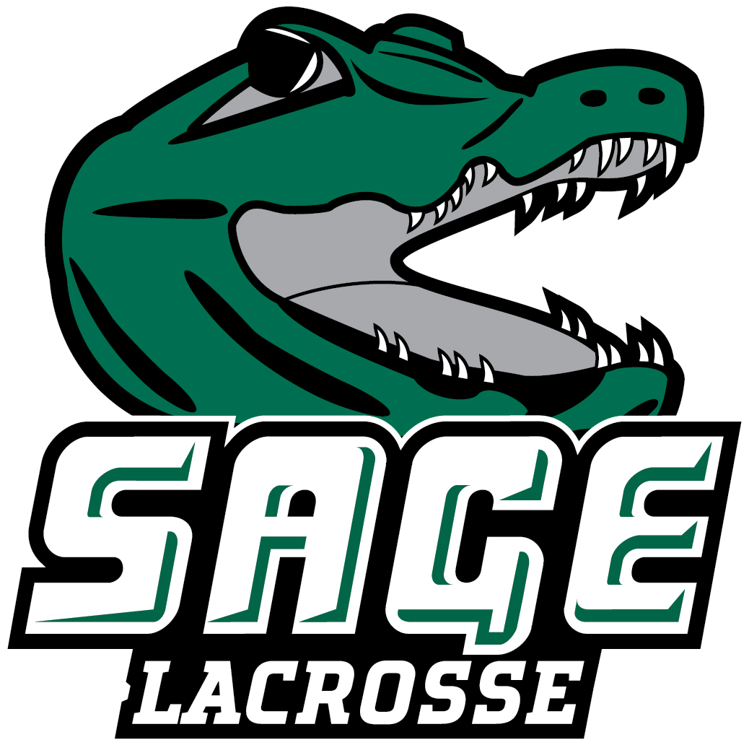

2026 RUSSELL SAGE COLLEGE MEN’ S LACROSSE
Office of Athletic Communications 140 New Scotland Avenue • Albany, NY 12208
www.sagegators.com

NO. NAME POS. YR. HT. WT. HOMETOWN/HIGH SCHOOL/PREVIOUS
1 Gamo Koulibaly M Sr. 5-10 180 Aurora, CO/Rangeview
2 Brady Dubay D Sr. 6-7 255 Altamont, NY/CBA
3 Garrison Decker M So. 5-11 200 Windsor, NY/Windsor Central
5 Andrew Cevallos G Fr. 6-2 300 Yonkers, NY/Saunders Trade and Technical
8 Ashton Bombard M Jr. 5-8 165 Troy, NY/LaSalle Inst.
9 Clarence Lowrie M So. Bronx, NY/
11 Aaron Alvarez D Fr. 5-10 200 Asheville, NC/TC Robertson
12 Dylan Baisley M Fr. 5-10 170 Monroe, NY/Monroe-Woodbury
14 Carson Pesce M So. 5-10 155 Monroe, NY/Monroe-Woodbury
20 Jacob Washington D So. 6-1 192 New York, NY / Frederick Douglass Academy
21 Mason Marckres G So. 5-9 165 Essex Junction, VT/Essex
22 Ryan Blake M Gr. 5-7 170 Rensselaer, NY/Columbia/Salisbury
29 Drake Krajewski M Jr. 6-0 195 Tivoli, NY/Red Hook
30 Andrew Collora M/G Sr. 6-2 180 West Babylon, NY/West Babylon
41 Mame Diba A Sr. 6-4 190 New York, NY/Haldane
42 Ricardo James M So. 5-9 140 Brooklyn, NY/John Jay
44 Doan Sangare M So. 6-0 155 New York, NY/Frederick Douglass Academy
55 Andrew Meyer D So. 5-9 190 West Babylon, NY/West Babylon
77 Matthew DeSocio D Sr. 6-0 165 Queensbury, NY/Queensbury
99 Jordon Hankel G So. 5-10 158 Cold Spring, NY/Haldane

Head Coach: Erich Skelly (SUNY Brockport ’10, Second Season)
Assistant Coaches: Lucas Maloney (Penn State ’17, Second Season)
Chris Joyce (Saint John’s ’11, Sixth Season)
Volunteer Assistant Coaches: Glen Somers and John Hankel
Captains: #2 Brady Dubay, #14 Carson Pesce and #99 Jordon Hankel

Pronunciation Guide:
1 Gam-mo Kool-lee-ba-lee
2 Do-bay
5 See-va-los
12 Bays-lee
14 Pe-shh
21 Mark-ress
29 Kra-jew-ski
44 San-gar-ray
99 Hay-cull
HC Eric Skel-lee
AC Hay-cull
March 25, 2026

