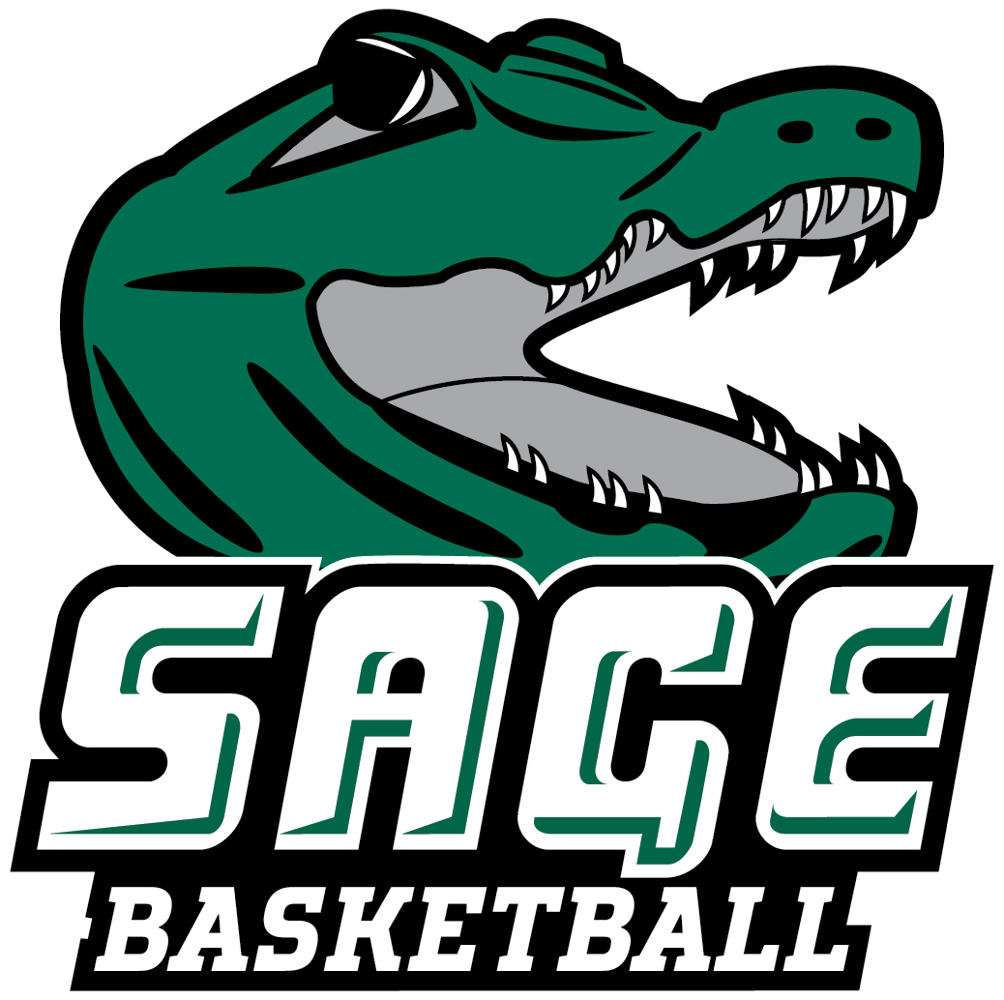
2022-23 RUSSELL SAGE COLLEGE WOMEN’ S BASKETBALL
“THE GATORS”

No. Name Pos. Cl. Ht. Hometown/High School/Previous School
1 Shauna Ferris ** G Jr. 5-7 Cohoes, NY/Cohoes
2 Olivia Huneau* G So. 5-7 Cohoes, NY/Cohoes
3 Layla Acosta G Fr. 5-7 Haines City, FL/Haines City
4 Madison Huneau G Fr. 5-6 Cohoes, NY/Cohoes
5 Giuliana Pritchard F Gr. 5-10 Amsterdam, NY/Amsterdam/Hartwick
10 Gwen Eichen* G So. 5-8 Moriah, NY/Moriah Central
11 Lily Batule*** G Sr. 5-9 Slate Hill, NY/Minisink Valley
12 Aniyah Kelley F Fr. 6-0 New Castle, DE/William Penn
13 Allison Louque F Fr. 6-1 Westminster, MD/Winters Mills
14 Renna Poulin ** G Sr. 5-9 Troy, NY/Tamarac
15 Angelina Schaefer* G So. 5-5 Latham, NY/Shaker
22 Sammy Pasinella**** G Gr. 5-8 Mechanicville, NY/Mechanicville
24 Malena Gereau* G So. 5-7 Schroon Lake, NY/Schroon Lake Central
25 Lauren Sanderson* G So. 5-6 Ravena, NY/RCS
30 Syrita Faraj* G So. 5-9 Troy, NY/Tamarac
35 Caroline Iannotti G So. 5-7 Broadalbin, NY/Broadalbin-Perth/Fulton Montgomery CC
*Indicates Letters Won

Head Coach: Allison Coleman, Eastern Connecticut State ’04 (Ninth Season) - 125-77 (.619)
Assistant Coach: Michael Branche

Pronunciation Guide
2 Olivia Huneau Hue-No
4 Madison Huneau Hue-No
10 Gwen Eichen Eye-keen
11 Lily Batule Ba-tool
13 Allison Louque Luke
24 Malena Gereau Ja-Row
30 Syrita Faraj Fa-raj
34 Madison Huneau Hue-No
AC Michael Branche Branch

January 4, 2023

Office of Athletic Communications 140 New Scotland Avenue • Albany, NY 12208
P) 518.244.4767 F) 518.720.3007 W) www.sagegators.com E) kinga2@sage.edu

