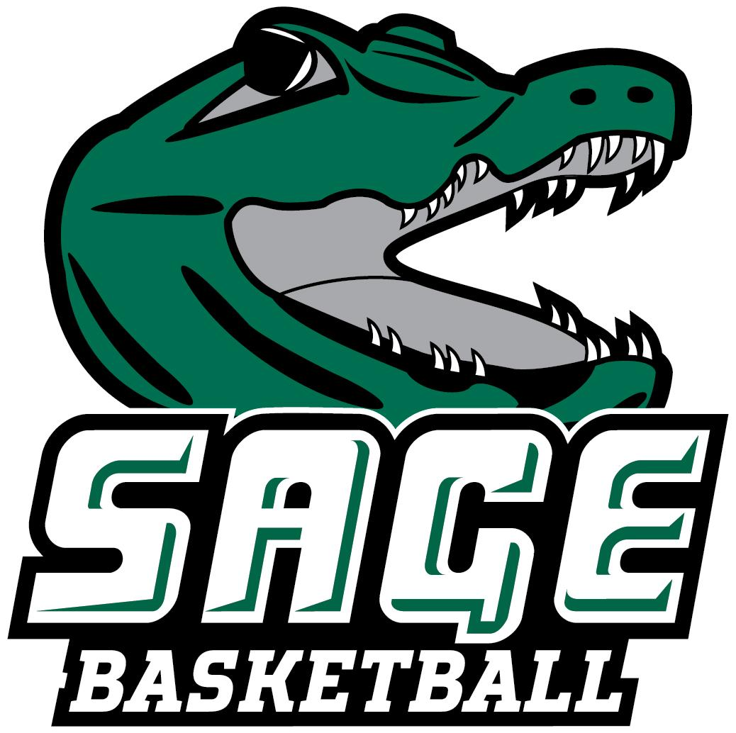
2025-26 RUSSELL SAGE COLLEGE WOMEN’ S BASKETBALL
“THE GATORS”

No. Name Pos. Cl. Ht. Hometown/High School/Previous School
1 Jaileen Soto G So. 5-4 Phillipsburg, NJ/Phillipsburg
2 Miranda Price G Fr. 5-0 Stillwater, NY/Stillwater
3 Layla Acosta G Sr. 5-7 Haines City, FL/Haines City
4 Madison Huneau G Sr. 5-6 Cohoes, NY/Cohoes
10 Kyla Smith G Gr. 5-6 Sprakers, NY/Fonda-Fultonville/SUNY Fredonia
11 Samantha Henderson F So. 5-6 Hillsdale, NY/Taconic Hills
12 Aniyah Kelley F Sr. 6-0 New Castle, DE/William Penn
14 Kallie Hopkins F Jr. 5-8 Millsboro, DE/Poly Tech
21 Danielle Waldron G/F Jr. 5-7 Cayuga, NY/Union Springs
23 Emily Zeh F Sr. 5-11 Oneonta, NY/Oneonta
24 Olivia Sheive G Fr. 5-8 Freeville, NY/Dryden
32 Isabella Clute G Fr. 5-9 Schenectady, NY/Mohonasen

Head Coach: Michael Branche (Second Season, Alfred ’14)
Assistant Coach: Eric Fluty
Graduate Assistant: Olivia Huneau ‘25
Volunteer Assistant: Lauren Sanderson ‘25

Pronunciation Guide
4 Madison Huneau Hue-No
14 Kallie Hopkins Cali
23 Emily Zeh Zee
24 Olivia Sheive Shy-ive (rhymes with chive)
32 Isabella Clute Cloot
HC Michael Branche Branch
AC Eric Fluty Flu-tee
GA Olivia Huneau Hue-No

November 15, 2025

Office of Athletic Communications 140 New Scotland Avenue • Albany, NY 12208
www.sagegators.com

