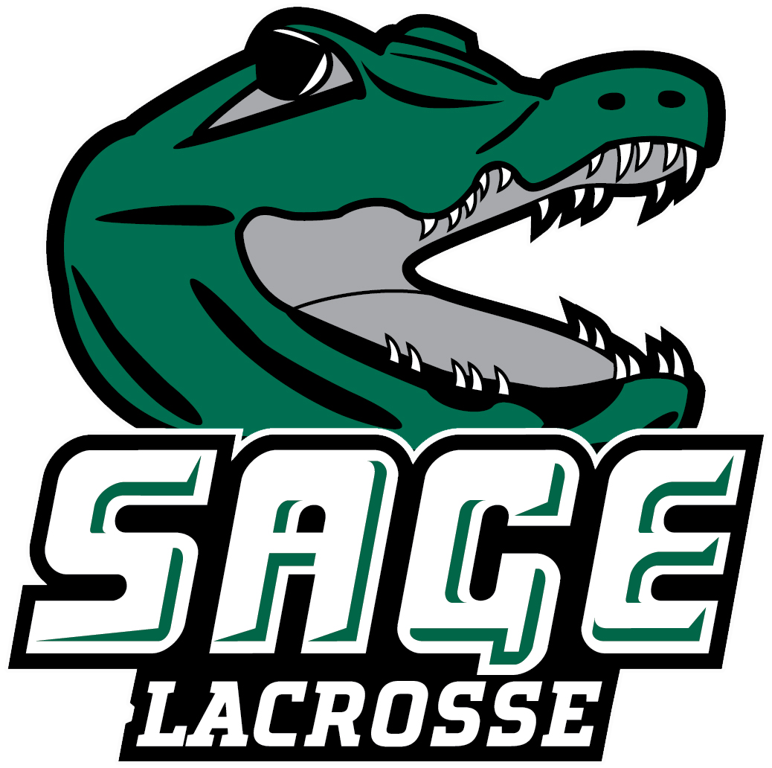

2026 RUSSELL SAGE COLLEGE WOMEN’ S LACROSSE
Office of Athletic Communications 140 New Scotland Avenue • Albany, NY 12208
www.sagegators.com

NO. NAME POS. YR. HT. HOMETOWN/HIGH SCHOOL
1 Eva Hirschoff M So. 5-5 Castleton-on-Hudson, NY / Maple Hill
2 Malissa Erickson A/M So. 5-1 Essex Junction, VT/Essex
3 Ashlyn Fish M Jr. 5-4 Gansevoort, NY / South Glens Falls/ King's
5 Alexis Crossman M Jr. 5-9 Corinth, NY/Corinth
7 Abigail Koennecke A/D Fr. 5-5 Delmar, NY/Bethlehem Central
8 Samantha Shafer A Gr. 5-6 Schenectady, NY/Schenectady
10 Sophia Frechette D Fr. 5-3 Scotia, NY/Scotia-Glenville
11 Grace Drenth Fr. M 5-4 Washingtonville, NY/Washingtonville
15 Gianna Geraci M Jr. 5-7 Averill Park, NY/Averill Park
16 Mackenna Huestis D Jr. 5-5 Gansevoort, NY/South Glens Falls
17 Madison Haviland D Fr. 5-3 Hoosick, NY/Hoosick Falls Central
18 Maia Hunter M So. 5-6 Theresa, NY/Indian River
20 Elizabeth Zollman A Jr. 5-6 Bethlehem, NY/Bethlehem
23 Zoe Gravina A/G So. 5-4 Albany, NY/Albany
24 Keegan Long A/G So. 5-5 Gansevoort, NY/Schuylerville

Head Coach: Geri Seif (First Season, Olivet ‘15)
Graduate Assistant Coach: Angelina Schaefer ‘25
Volunteer Assistant Coaches: Peggy Monti ‘25

Pronunciation Guide:
#7 Abigail Koennecke Conny-key
#10 Sophia Frechette Fur-chett
#11 Grace Drenth Dra-ength
#15 Gianna Geraci Jer-rah-see
#16 Mackenna Huestis Hues-tis
#17 Madison Haviland Have-a-land
HC Geri Seif Sife (Rhymes with Life)

April 22, 2026

