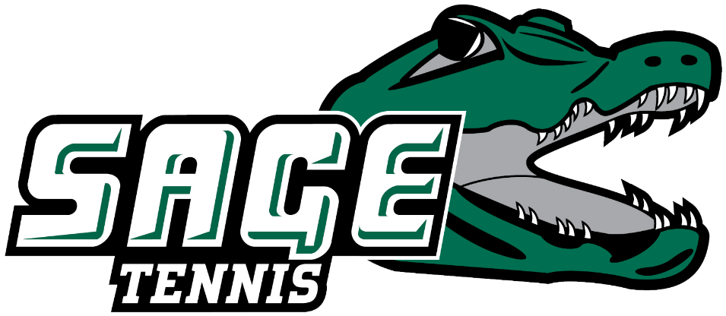
2025 RUSSELL SAGE COLLEGE WOMEN’S TENNIS
“THE GATORS”

NAME CL. HOMETOWN/HIGH SCHOOL
Mackenzie Clogston Jr. Bradford, VT/Oxbow
Moira Cruz Fr. Albany, NY/
Amber Elk Jr. Albany, NY/Colonie
Jessica Korbieh So. Albany, NY/Albany
Cami Lamora So. Troy, NY/Troy
Katie Snell Jr. Valley Falls, NY/Greenwich
Tirzah Spivey Sr. Clifton Park, NY/Schenectady

Head Coach: Taylor Gillespie (First Season, Russell Sage College ’22)

August 28, 2025

